Exercise 2: E-commerce Platform Search Function
- Understanding Asymptotic Notation -
Big O Notation is a mathematical way to describe the growth rate of an algorithm's running time or memory usage as the input size (n) increases. It focuses on the algorithm's worst-case performance and ignores constant factors and lower-order terms.

What Big O Notation Tells Us -
- Growth Patterns: It reveals how an algorithm slows down as it handles more data. Like knowing whether adding more stops to a delivery route will slightly increase your time (good) or make it take dramatically longer (bad).
- Worst-Case Planning: It prepares us for the toughest scenarios, like searching for an item that might not even be in our inventory.
- Comparison Tool: It lets us objectively compare different approaches to solving the same problem.

Complexity | Name | Example
O(1) | Constant Time | Accessing an array element
O(log n) | Logarithmic Time | Binary Search
O(n) | Linear Time | Linear Search
O(n log n) | Linearithmic Time | Merge Sort
O(n²) | Quadratic Time | Bubble Sort
O(2ⁿ) | Exponential Time | Recursive Fibonacci
O(n!) | Factorial Time | Traveling Salesman (Brute Force)

Real-World Search Scenarios -
Best-Case Performance (Dream Scenario) -
- Linear Search: You get lucky and find the product on your first try, like spotting the exact shirt you want right at the store entrance.
- Binary Search: The item happens to be exactly in the middle of your sorted inventory - one quick check and you're done.

Average Performance (Typical Day) -
- Linear Search: On average, you'll need to look through about half your inventory before finding what you need. More products means proportionally more time.
- Binary Search: Each step dramatically narrows down the possibilities, meaning even with thousands of products, you'll only need to check a handful.

Worst-Case Performance (Tough Day at Work) -
- Linear Search: The item isn't in stock or is the very last one you check - you've wasted time examining everything.
- Binary Search: Even in the worst case, the number of checks grows very slowly compared to the inventory size - what takes 10 checks for 1,000 items might only take 15 checks for 10,000 items.

2,3 – Setup and Implementation -

import java.util.ArrayList;
import java.util.Collections;
import java.util.Comparator;
import java.util.List;
import java.util.Scanner;

class Product {
private int productId;
private String productName;
private String category;
private double price;

public Product(int productId, String productName, String category, double price) {
this.productId = productId;
this.productName = productName;
this.category = category;
this.price = price;
}

public int getProductId() {
return productId;
}

@Override
public String toString() {
return String.format("Product(ID: %d, Name: '%s', Category: '%s', Price: $%.2f)",
productId, productName, category, price);
}
}

public class ECommerceSearch {

// Linear search func
public static Product linearSearch(List<Product> products, int targetId) {
for (Product product : products) {
if (product.getProductId() == targetId) {
return product;
}
}
return null;
}

// Binary search func
public static Product binarySearch(List<Product> sortedProducts, int targetId) {
int low = 0;
int high = sortedProducts.size() - 1;

while (low <= high) {
int mid = (low + high) / 2;
int currentId = sortedProducts.get(mid).getProductId();

if (currentId == targetId) {
return sortedProducts.get(mid);
} else if (currentId < targetId) {
low = mid + 1;
} else {
high = mid - 1;
}
}
return null;
}

public static void main(String[] args) {
// Initializing product list
List<Product> products = new ArrayList<>();
products.add(new Product(101, "Laptop", "Electronics", 999.99));
products.add(new Product(203, "Smartphone", "Electronics", 699.99));
products.add(new Product(305, "Headphones", "Electronics", 149.99));
products.add(new Product(412, "Desk Chair", "Furniture", 199.99));
products.add(new Product(523, "Coffee Maker", "Appliances", 79.99));

// Creating sorted copy for the binary search
List<Product> sortedProducts = new ArrayList<>(products);
Collections.sort(sortedProducts, Comparator.comparingInt(Product::getProductId));

Scanner scanner = new Scanner(System.in);

System.out.println("E-commerce Product Search System");
System.out.println("--------------------------------");

while (true) {
System.out.println("\nSearch options:");
System.out.println("1. Linear Search");
System.out.println("2. Binary Search");
System.out.println("3. Exit");

System.out.print("Enter your choice (1-3): ");
String choice = scanner.nextLine();

if (choice.equals("3")) {
System.out.println("Exiting...");
break;
}

System.out.print("Enter product ID to search: ");
try {
int targetId = Integer.parseInt(scanner.nextLine());

Product result = null;
if (choice.equals("1")) {
System.out.println("\n Performing LINEAR SEARCH...");
result = linearSearch(products, targetId);
} else if (choice.equals("2")) {
System.out.println("\n Performing BINARY SEARCH...");
result = binarySearch(sortedProducts, targetId);
} else {
System.out.println("Invalid choice. Please try again.");
continue;
}

if (result != null) {
System.out.println(" Product found: " + result);
} else {
System.out.println(" Product not found");
}

} catch (NumberFormatException e) {
System.out.println("Please enter a valid number for product ID");
}
}

scanner.close();
}
}

Output-
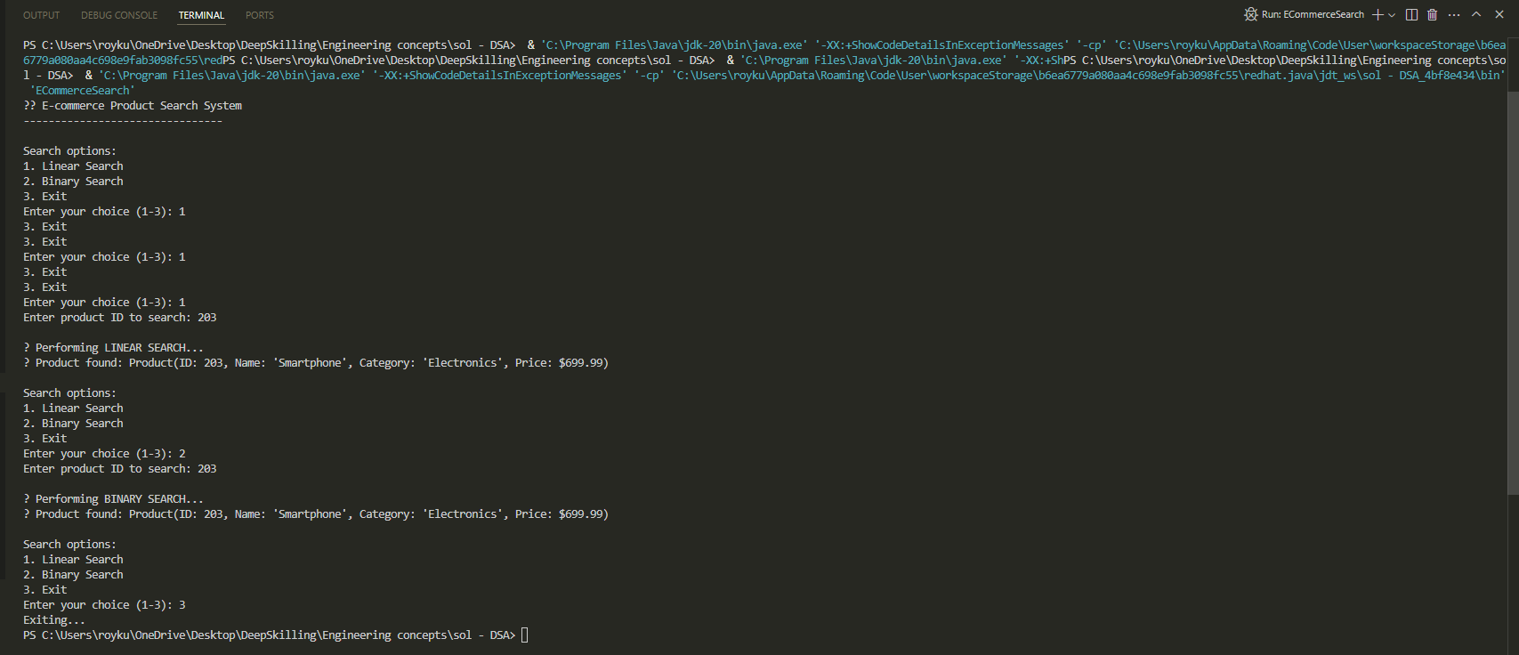

Try these test cases:
- Search for existing product IDs (101, 203, 305, 412, 523)
- Search for non-existent IDs
4. Analysing Search Algorithms for E-Commerce –
For e-commerce platforms, search efficiency impacts user experience. Binary search (O(log n)) excels when:
- Products are sorted by ID
- The catalog is large
- Searches are frequent
Linear search (O(n)) works better when:
- Searching by unsortable fields (name, description)
- The inventory changes often
- The product count is small
5. Recommendations:
- Use binary search for ID lookups on sorted data
- Apply linear search for flexible queries
- For massive catalogs, consider hash tables or search engines like Elasticsearch
Binary search is faster but requires sorted data. Linear search is simpler but slower for large datasets. Choose based on your catalog size, search frequency, and performance needs. For most platforms, a hybrid approach works best—optimizing common searches while keeping others flexible.

